Name: Hamza Ahmed Siddiqui
ID: FA17-BECE-0026

SHOW PRESENT WORKING DIRECTORY:
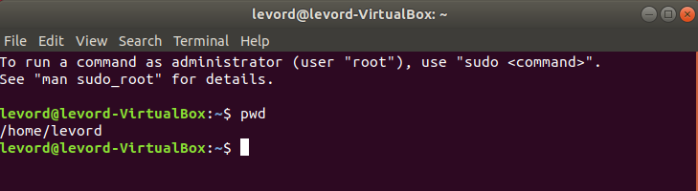

DATE & TIME COMMANDS:
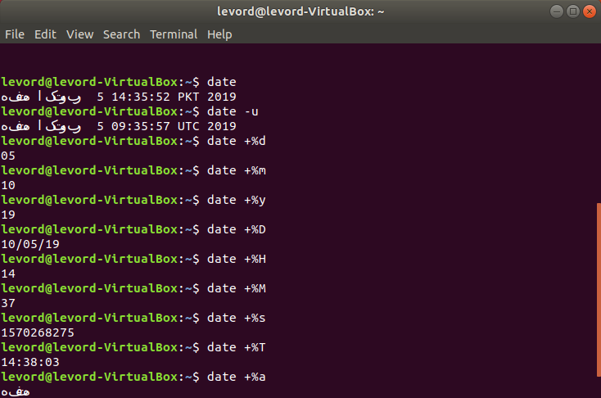

CREATING A DIRECTORY:
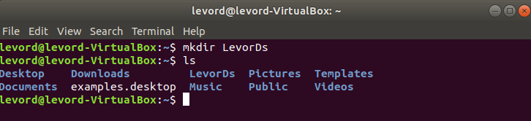
LISTING DIRECTORIES CONTENTS:
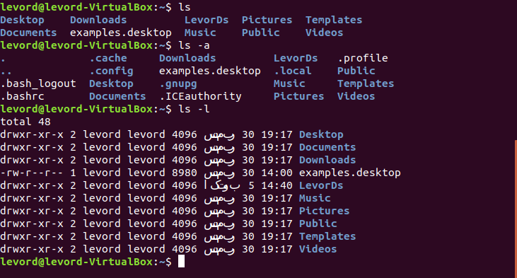
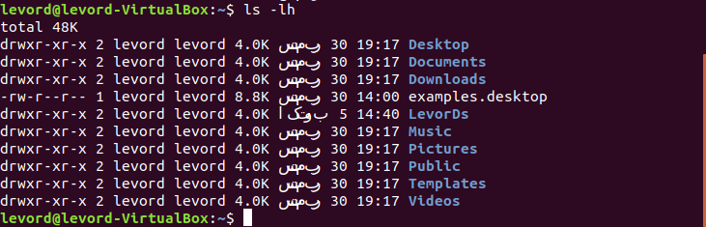

CHANGING DIRECTORIES:
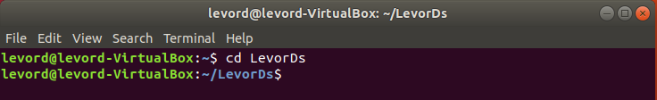
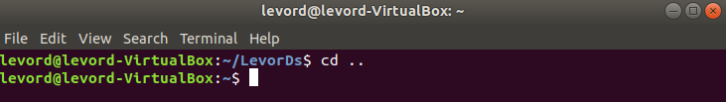
REMOVING DIRECTORIES:
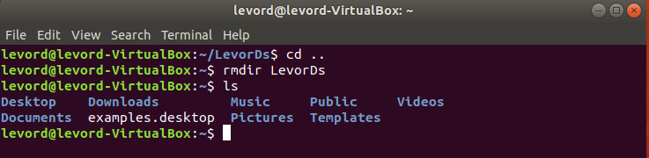
DISPLAYING BUILTIN LINUX COMMANDS FROM MANUAL:
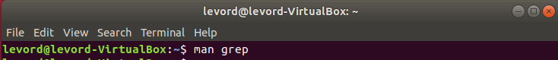
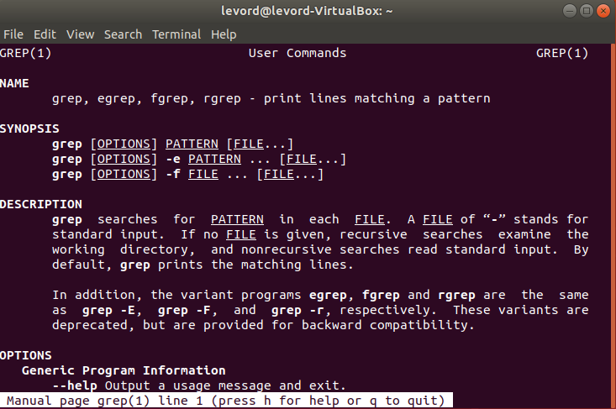
PROCESSES COMMANDS:
